**River project**

**The Scioto**

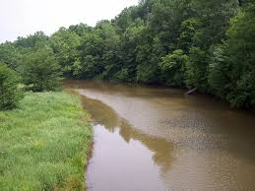

map of river

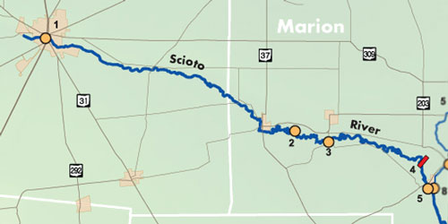

Creatures that live in the river:

HUGE catfish,

Saugers,

Walleyes,

White bass,

Blue gills,

Yellow perch,

Sauger,

Brown trout

Large mouth,

Crappies,

Muskies,

Small mouth and

Bass.

What countries the Scioto flow through:

The Scioto River flows south through much of the state of Ohio. It begins near the town of New Hampshire, OH and empties into the Ohio River near the city of Portsmouth, OH which is a distance of about 231 miles.